

**Importance of saving and the role of MF in our savings & investments**

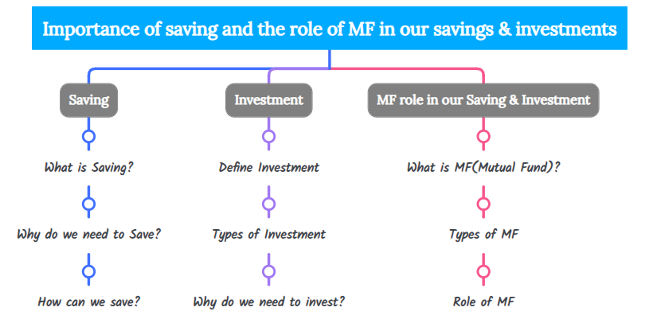

**What is Saving?**

Saving is the portion of income not spent on current expenditures. In other words, it is the money set aside for future use and not spent immediately.

**Why do we need to save?**

We need to save money to accomplish goals in the short-term such as buying an iPhone, or in the long run such as buying a car or a house.

**How can we save?**

The first and foremost step in knowing how can we save is to figure out the difference in money between your income and expenses. It may be in minus number or a positive number. If our difference is in minus number then we have to check our expense(spending) list for our spending on non-essential things, such as lavish spending, and try to cut it down to the maximum extent to save our money for our near and far future requirements. If our difference is in a positive number then start making an investment to accumulate it further.

**Define Investment**.

The act of putting money into something to allow money to grow (make a profit or get an advantage).

**Types of Investment**.

* Growth-oriented investments
* Fixed-income investments
* ***Growth-oriented investments***

Growth-oriented investments are primarily focused on maximizing capital appreciation. In other words, it’s a strategy that is focused on increasing an investor's capital.

Examples: Stocks or Stock mutual funds.

* **Fixed-income investments**

Fixed-income investments are an **investment** approach focused on the preservation of capital and income.

Examples:  government and corporate bonds, certificates of deposit (CDs), and money market funds.

**Why do we need to invest?**

We need to invest our surplus hard-earned income to build our wealth, in simple terms, we need to invest money in order to achieve our short-term and long-term financial goals.

**Short-term goals?**

A financial goal that is to be achieved within 12 months (i.e 1 year) is said to be a short-term goal.

Examples: School/ college fees. Paying a premium for our vehicle, medical and life insurance, buying birthday or any celebration gifts for our loved ones.

**long-term financial goals**.

A financial goal that is to be achieved 1 year and above is said to be a long-term goal.

Examples:-Buying any real estate property (House, Farmhouse, etc.,), retirement planning.

**What are Mutual Funds**?

A mutual fund is an investment vehicle where multiple investors come together and pool their funds. This pooled money is then invested by the fund manager across various asset classes including equity, debt, gold, and other securities to generate returns. The gains and losses incurred from such investments are divided among investors in the proportion of the share of investment.

**Types of Mutual Fund**.

There are basically 3 types of investments.

1. Equity funds
2. Debt Funds
3. Hybrid Funds

**Equity funds**

Equity funds are growth funds that invest in the share/stocks of companies and aim to get a higher return.

**Types of Equity funds**.

1. Large-cap funds
2. Mid-cap funds
3. Large and Midcap Funds
4. Small-cap funds
5. Multi-cap funds

**Benefits of Equity funds**.

1. Diversification
2. Better inflation-adjusted returns
3. Expert Management
4. Convenience
5. Tax Benefits
6. Start small

**Debt funds**

Debt funds a.k.a Income funds or Bond funds

It’s an MF Scheme that invests in fixed income instruments, such as Corporate and Government Bonds, corporate debt securities, money market instruments etc. that offer capital appreciation.

**Types of debt funds**.

* Overnight funds
* Liquid funds
* Ultra-short Duration funds
* Low Duration funds
* Money market funds
* Short Duration funds
* Medium Duration funds
* Medium to long Duration funds
* Long Duration funds
* Dynamic bond funds
* Corporate bond funds
* Credit risk funds
* Banking and PSU funds
* Gilt funds
* Gilt fund with 10-year constant Duration
* Floater funds

**Benefits of DEBT funds**

1. High on Liquidity
2. Relatively stable and safe
3. Tax Efficiency
4. Risk Reduction by diverfication
5. Aim for better returns than traditional investment instruments

**Hybrid Funds (aka Balanced funds)**

Hybrid funds are one of the mutual fund schemes that invest in more than one asset class i.e. equity, debt, and other asset classes depending on the investment objective of the scheme. These funds invest in a mix of different asset classes to diversify the portfolio with an aim to minimise the risk involved.

**Types of Hybrid Funds**

* Aggressive Hybrid Fund
* Conservative Hybrid Fund
* Dynamic Asset Allocation Fund
* Multi Asset Allocation Fund
* Arbitrage Fund
* Equity Savings Fund

**Benefits of Hybrid funds**

1. To generate better returns than debt funds
2. Diversified exposure to both equity and debt markets
3. Allows investors to balance risk and return
4. Tax Advantage

**Role(benefits) of Mutual funds**

* Risk Diversification
* Smaller capital outlay
* Investment expertise
* Economies of scale in transaction costs
* Variety of products
* Variety of modes of investments
* Variety of investment objectives
* Liquidity
* Tax advantage

**Risk Diversification**

* Risk Diversification is also known as asset allocation.
* Every stock is subject to three types of risk – company risk, sector risk and market risk. Company risk and sector risk are unsystematic risk, while market risk is known as systematic risk. Mutual funds help investors diversify unsystematic risks by investing in a diversified portfolio of stocks across different sectors. While individual stocks have both unsystematic and systematic risks, mutual funds are only subject to systematic risk or market risk.

**Smaller capital outlay**

* It allows the investor to start investing relatively small amounts in Mutual funds.
* Investors can buy units of a diversified equity mutual fund with an investment as low as Rs 5,000/- only or even lower at Rs 500 for ELSS schemes.

**Investment expertise**

* Your invested funds are managed by professional fund managers who have the desired qualification, expertise and experience in picking the right stocks or other instruments to get the best risk adjusted returns.

**Economies of scale in transaction costs**

* Lower transaction cost due to economies of scale is another **advantage of mutual funds.** Since mutual funds buy and sell securities in large volumes transaction costs on a per unit basis is much lower than what retail investors may incur if they buy or sell shares through stock brokers.

**Variety of products**

* Mutual funds offer investors a variety of products to suit their risk profiles and investment objectives. Apart from equity funds, there are hybrid funds, debt funds, liquid funds and tax savings schemes etc. to suit different investment requirements. The **benefits of investing in mutual funds** is that you can invest in the appropriate product suitable for your specific needs and risk appetite.

**Variety of modes of investments**

* Flexibility in terms of modes of investment and withdrawal is one of the advantages of mutual funds compared to other investment options. Investors can opt for investment modes like lump sum (or one time), systematic investment plans (SIP), systematic transfer plans (STP) and systematic withdrawal plans (SWP).

**Variety of investment objectives**

* As an investor we can meet various types of investment objectives like capital appreciation and income. Equity mutual funds can help you create wealth through capital appreciation, while debt mutual funds can generate income for you. Hybrid mutual funds can help you in both capital appreciation and wealth creation.

**Liquidity**

* Investors can redeem their units in open ended funds usually on a T+3 (transaction + 3 days) basis.
* Liquid, overnight, low duration and ultra-short funds can usually be redeemed on T+1 day.

**Tax advantage**

* Mutual fund tax benefits under Section 80C
* Investments in [Equity Linked Savings Schemes](https://www.miraeassetmf.co.in/mutual-fund-scheme/equity-fund/mirae-asset-tax-saver-fund) or ELSS mutual funds qualify for deduction from your taxable income under Section 80C of the Income Tax Act 1961.
* The maximum investment amount eligible for tax deduction under Section 80C, is Rs 1.5 lakhs.
* Investors in the highest tax bracket (30%) can therefore save up to Rs 46,350 in taxes (Rs 1.5 lakhs X 30.9% tax + cess) by investing in [ELSS mutual funds](https://www.miraeassetmf.co.in/mutual-fund-scheme/equity-fund/mirae-asset-tax-saver-fund).
* Investor should note that, Rs 1.5 lakhs is the overall 80C cap including all eligible items like, employee provident fund (EPF) contribution (deducted by your employer), PPF, life insurance premiums, NSC and ELSS mutual funds etc.