

***Devaki’s Guide to Traditional Marketing vs Digital Marketing.***

*Are we ready to explore Devaki’s Guide to know the basics of traditional marketing vs digital marketing?*

*In this article, I am going to share some of the marketing concepts & techniques in general that everyone should know during their lifetime for better living personally and professionally. This article will be useful for a common man, who might be a beginner, updater & explorer.*

***Fundamentals of Marketing:***

***Marketing:***

*In simple terms, marketing is all about an in-born technique which is used by all of us to promote/sell ourselves and our products/services.*

***Principles OF MARKETING(5’Ps):***

There are five Ps of marketing — **product, price, place, promotion, partner** — are often referred to as the marketing mix. These are the key elements involved in marketing a goods or services, and they interact significantly with each other.

Example: Russia and Ukraine war continues and global market inflation and interest rate increases, it may end up with stagflation (Low economy growth and High inflation), So we should keep an eye on current situation & give importance to choose Alternative goods (Electric Vehicles) instead of commodity-based goods (Petrol Vehicles).

***Digital Marketing vs Traditional Marketing: -***

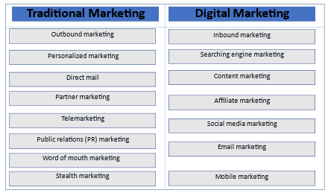

**Traditional Marketing:**

**1. Outbound marketing**

When a marketing strategy is referred to as “outbound,” it’s focused on how the message is being delivered. Outbound marketing happens when a company shares their message out to an audience. Billboard advertisements are a good example of outbound marketing — in the case of a billboard, the company is trying to share certain information out to the people driving by.

**2. Personalized marketing**

Personalized marketing is a strategy in which the company uses historical data to create a personalized experience for you. This could include direct mail that uses your name in marketing materials or grocery stores that offer you coupons for items you regularly purchase.

**3. Direct mail**

Direct mail is when companies send advertisements to a specific address. This allows businesses to target a specific area. A good example of direct mail marketing is a weekly grocery store advertisement.

**4. Partner marketing**

The partner marketing strategy requires two companies to work together to create one cohesive message. A common example of this is a company sponsoring something at another company. For example, a cafe may provide free WiFi courtesy of Google.

**5. Telemarketing**

Telemarketing is when a company reaches out to individuals via phone calls. This is still a common tactic, but since cell phones and caller ID have become the norm, the success of this marketing strategy has dwindled.

**6. Public relations (PR) marketing**

PR marketing is a strategy where you partner with a news source to generate more buzz around your business. PR marketing is commonly used when a company launches a new product, has a major change of leadership, or announces an expansion.

PR marketing might not directly promote a product, but it’s a good way of increasing brand awareness for your business. This is especially relevant in B2B marketing, because some business buyers will make decisions based on their understanding of your company’s position in the competitive landscape.

**7. Word of mouth marketing**

Word of mouth marketing is a marketing strategy that relies on existing customers referring your business to new customers. This is a hard strategy to control, because it depends on your customers to do the leg work.

A common way to encourage customers to refer friends is to offer some kind of incentive, such as a discount or bonus for referring your business. This is commonly seen in small businesses that are client-based, like hair salons or gyms. This is also starting to happen more for subscription-based services such as meal delivery services. If you refer a friend, both you and a friend may get some kind of discount.

**8. Stealth marketing**

Stealth marketing is the act of marketing a good or service to someone without them realizing they’re being marketed to. A good example of this is product placement in a movie or TV show. You may notice that certain characters in the show only use a certain type of computer, or only drive a certain type of car. This is because those companies paid to be featured.

**Digital Marketing:**

**1. Inbound marketing**

Inbound marketing is a strategy used to bring potential customers to you instead of sharing a message out. This is a long-term strategy that involves many different types of digital marketing tactics to encourage a potential customer to move further down the marketing funnel.

Inbound marketing uses search engine optimization (SEO) strategies, content marketing, and email marketing to educate and encourage potential customers to interact with a brand or business more frequently.

**2. Searching engine marketing**

Search engine marketing is the strategy of utilizing search engines such as Google. Search engine marketing can include paid advertisements such as pay-per-click (PPC) advertisements and suggested posts. It can also include organic SEO strategies, such as creating optimized content in the hopes of ranking highly on Google.

**3. Content marketing**

Content marketing involves creating content, such as eBook’s or webinars, to encourage potential customers to interact with your brand more frequently. The goal of content marketing is for potential customers to share some information, such as an email address, so the company can continue marketing to you in different ways.

**4. Affiliate marketing**

Affiliate marketing is a strategy in which a company pays commission to an external website for sales that are generated via their website referrals. This is commonly used in combination with influencer marketing strategies to target a very focused demographic of consumers.

**5. Social media marketing**

Social media marketing uses social media platforms as a key channel to share your messaging. Social media marketing can be paid ads, organic content, or user-generated content. Social media marketing is commonly used by e-commerce businesses.

**6. Email marketing**

Email marketing is a strategy where you send potential customers marketing messaging through email. It’s used in both B2B and B2C marketing strategies and is one of the most effective ways to ensure you’re hitting your target market. One of the major benefits of email marketing is that it’s easy to implement some sort of segmentation in your marketing messaging. If you’re looking to test which audiences respond to certain messages, this is a good marketing strategy to use.

**7. Mobile marketing**

Mobile marketing involves sending marketing messages via push notifications or text messages. This tactic can be used to achieve many different goals, such as encouraging app openings to increase daily active users or to share coupons with discounts, like you would with email. The downside of this form of marketing is that you need customer phone numbers, and that information is harder to get than email addresses.

***CATT Marketing Funnel: -***

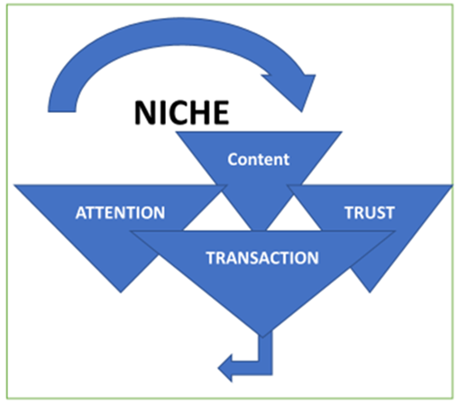

***EXAMPLE;***

***To promote a new hotel, first we should get complete details and should experience about the hotel. Then we should start writing about our experience with honest facts and figures. This quality content will give us more attention and later if the customer experiences the same in the hotel it will build a trust and once this stage passes successfully, we will automatically push the next level of transaction.***

***Integrated Digital Marketing: -***

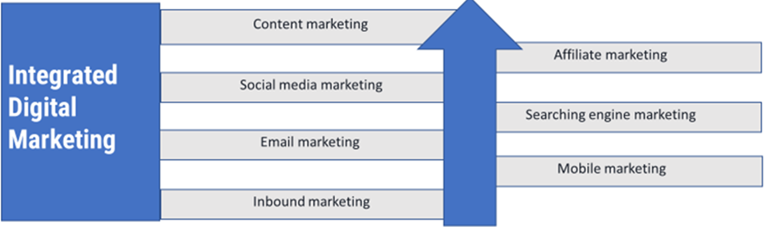

***Example: Somebody wants to sell Insurance Policy this module will help get more mind share about the concepts. B’Cos insurance in concept selling and emotion too.***

***Personal Branding: Mass Trust Blueprint: -***

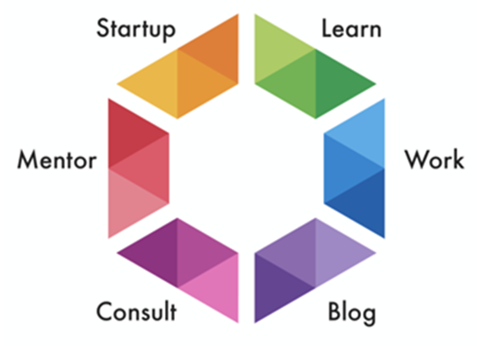

***My own example:***

*My goal was to become an entrepreneur since my childhood days.*

*Learn- so, keeping that in mind I took Arts (commerce, accountancy) group as my major in Higher secondary and I graduated in B.com (computer applications) and post graduated in MBA(Finance).*

*Note: As we know learning (doesn’t ends with our regular graduation cycle) is a continues process in our life time. Based on this, during my 10+ years of full-time work cycle, I have done some of the certification courses (to upskill and enhance my work) like Insurance agent -IRDA; Mergers & Acquisitions- Bombay stock exchange; Equity, Derivative series eight- National Stock exchange. And I am glad/grateful to say that am currently pursuing “Digital marketing internship with Learntoday.com (Digital Deepak.com)”.*

*Work/Blog/Consult/Mentor -followed my post-graduation, I started my career in financial services industry as a financial planning consultant (Mutual funds, Insurance, IPO, FD’s, stock market Trading) then I moved to Education industry as an Assistant professor/teacher/evening in-charge and followed that I worked as a Researcher specialist (Executive profile research, company research, corporate action research- Mergers & Acquisitions department of a KPO).*

*Start up: Very recently I started my B2B start-up (Bharath Fintech Solutions), where am acting as a business development partner (Financial planning-Tax planning, Mutual funds, PMS, AIF, NPS, Insurance, etc.;); channel partner 1 (Dubai UAE-travel tourism- 30 days/90 days Visit/tourist- Visa services, Job hunter packages, Holiday packages, Business travel); channel partner 2 (Health-Organic wood pressed groundnut/gingelly oil) and Reference partner (non-academic education classes — Abacus, Math’s/Hindi tuitions, Tamil language learning, phonetics) for my clients.*

*Note: to be up to date/upskill me, am also working as a Freelancer for my Domestic/International clients.*

***Conclusion: -***

So that brings us to the end of the article in which we talked about *Devaki’s Guide to Traditional Marketing vs Digital Marketing*I believe that you could now get a better picture of the *basics about traditional marketing vs digital marketing*after reading this article. And let me know in the comment, if you were able to relate to the examples or if you have any other real-life examples to share.*Happy Sharing!*